Analyzing Insecure Randomness in Session Token Generation of an Android Application

Chenru Hang Haoru Bai Haochen Peng
Jiayin Li Pranav Phirke Xiaohan Gao

Abstract
This report presents a static analysis of an Android application focusing on randomness and cryptographic usage. We identify that session tokens are generated using java.util.Random, which is predictable and unsuitable for security-sensitive contexts. This weakness may allow attackers to predict or forge tokens, leading to session hijacking. We propose mitigation using cryptographically secure randomness and improved session management.
Task 1: APK Unpacking and Decompilation
1.1.Define APK, decompile
APK (Android Package Kit) is the installation package format for Android system apps. The contents of an APK include already compiled code and resource files, so researchers cannot directly read its internal logic. Therefore, in security audits, it is necessary to first decompile the APK, restore it to readable code and configuration files, which is convenient for subsequent analysis, and also facilitates access to the package name, main Activity, manifest, and at least one login/registration-related class.
1.2.Tools and AI interaction
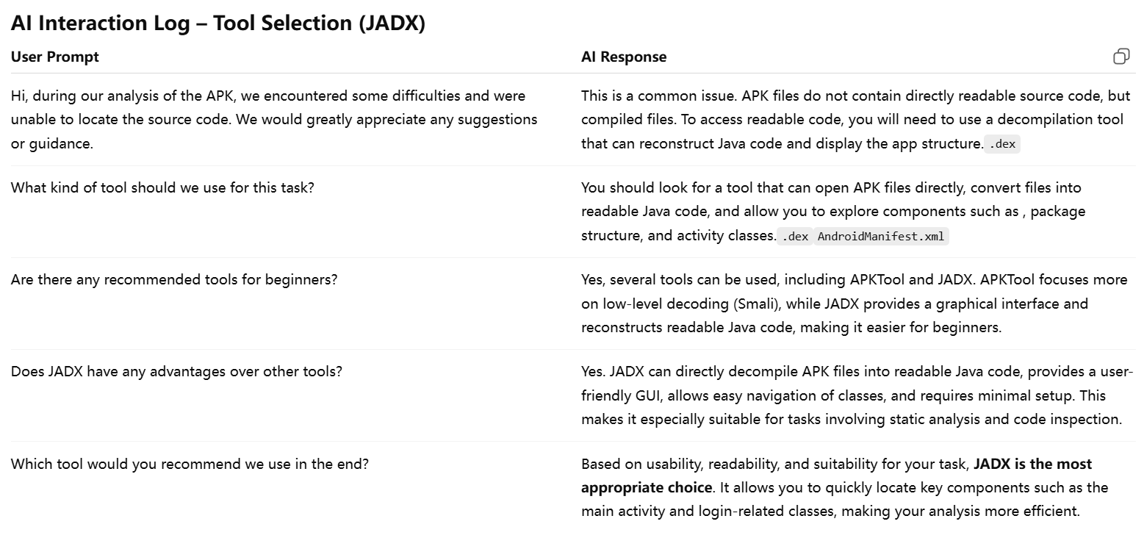
Figure 1
As shown in Figure 1, we interacted with ChatGPT and selected our decompilation tool - Jadx.
1.3.Decompilation result
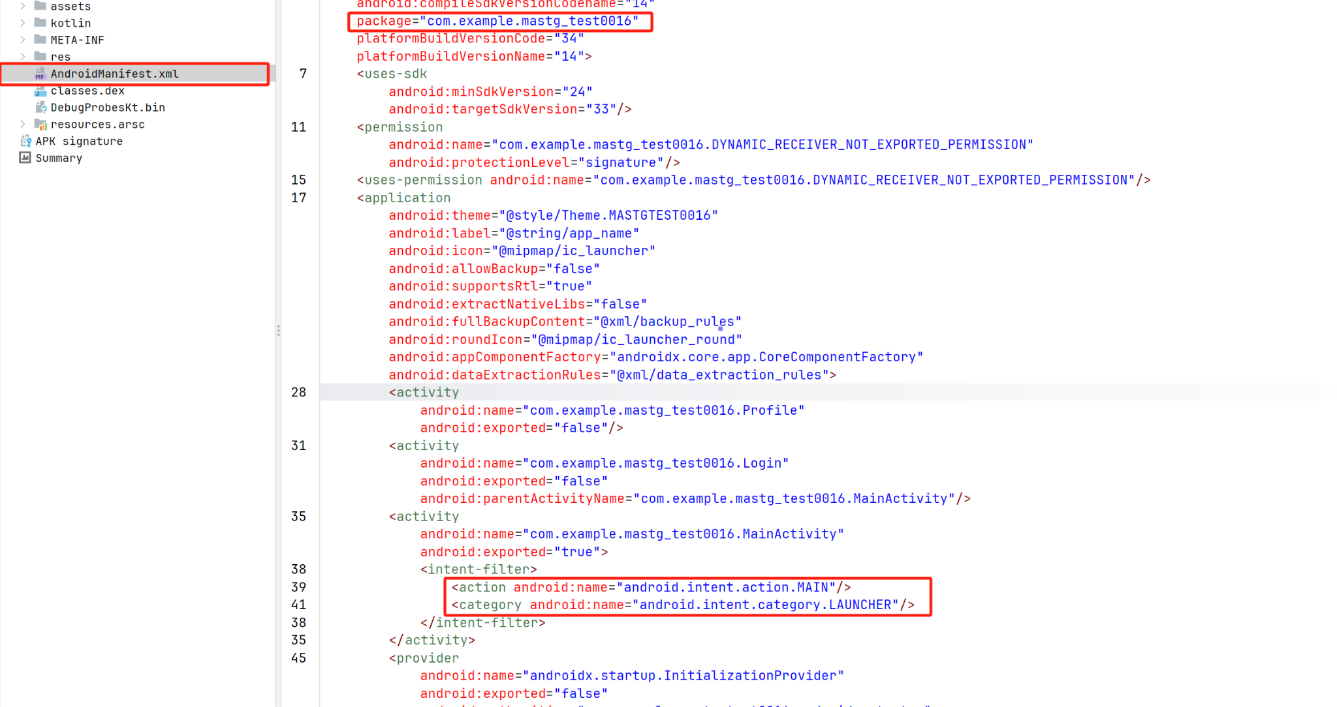
Figure 2
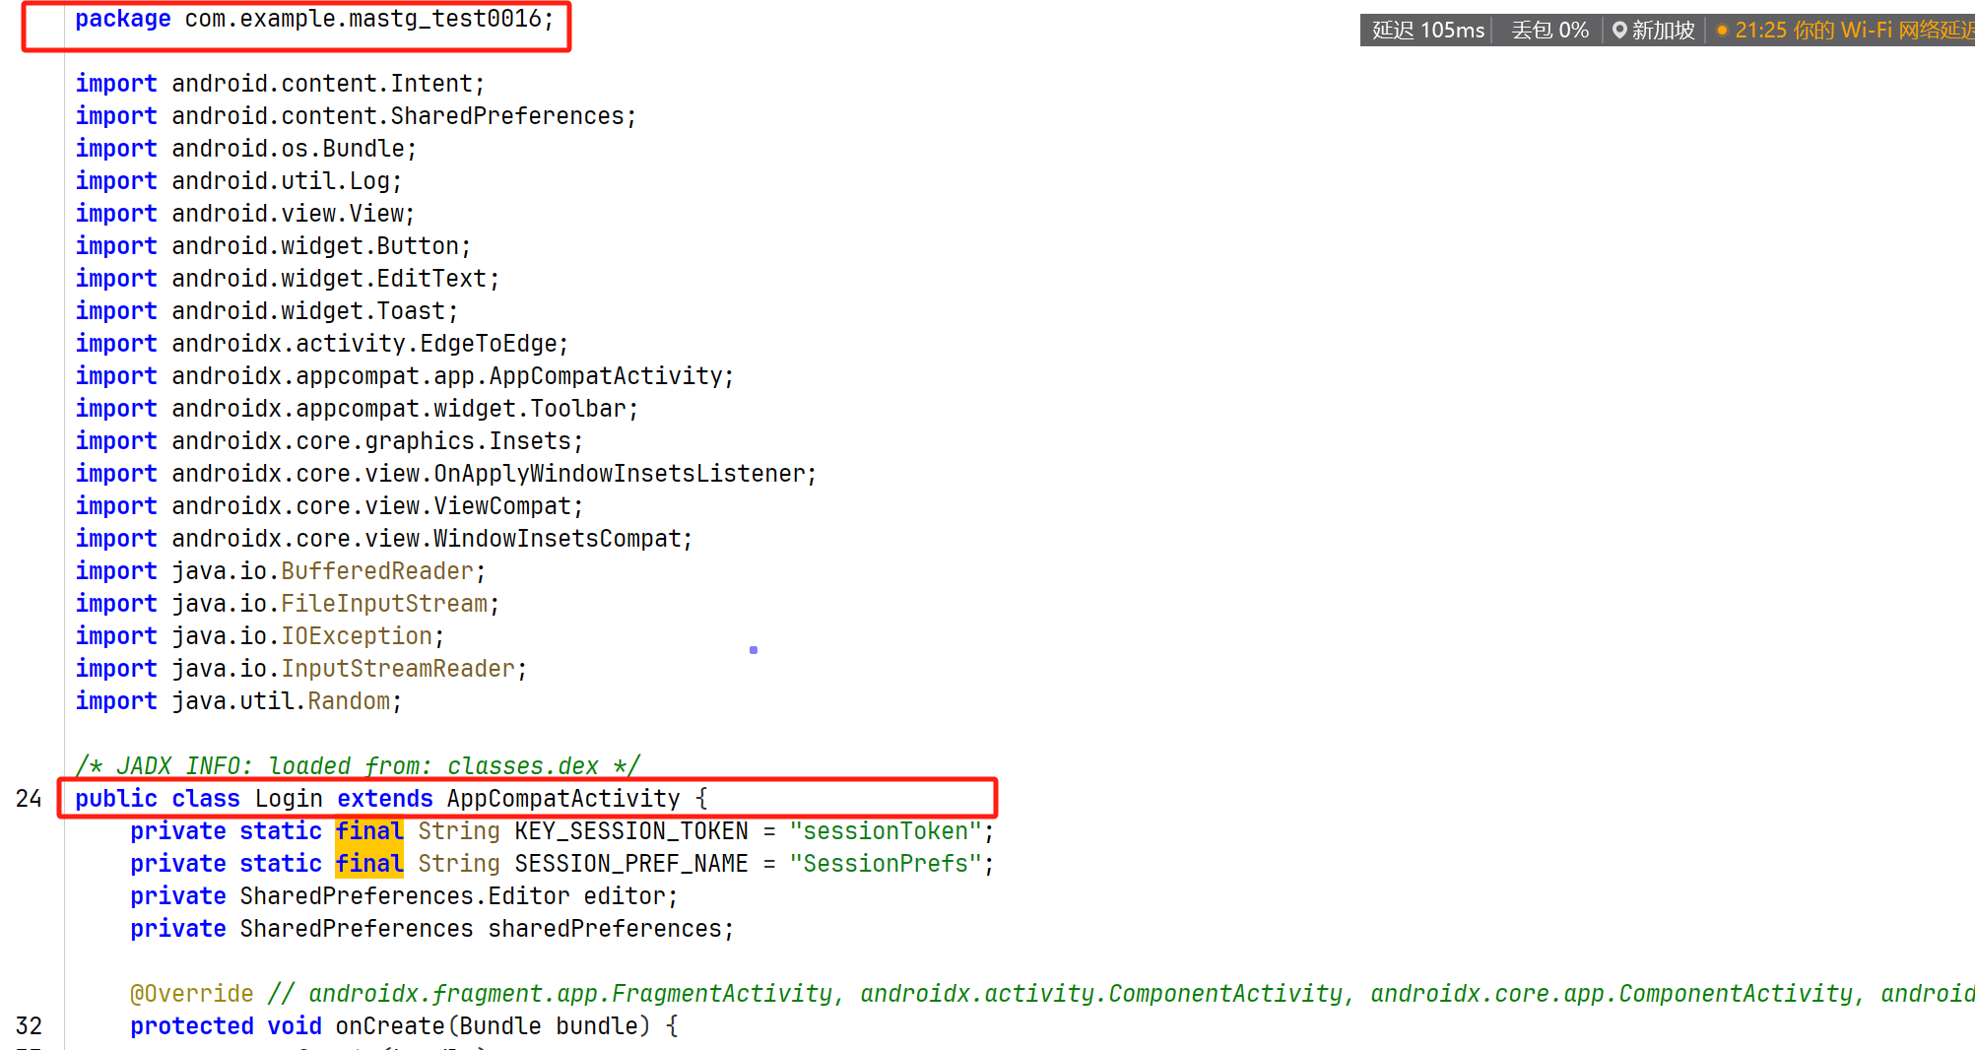
Figure 3
According to Figures 2 and 3, in the AndroidManifest.xml file, we identified that the application package name is com.example.mastg_test0016. Through the inclusion of MAIN and LAUNCHER in the intent-filter, we determined that com.example.mastg_test0016.MainActivity is the main entry Activity of the application. Additionally, we also identified the login-related class com.example.mastg_test0016.Login in the manifest. Furthermore, by examining the decompiled Java code, we further confirmed that Login belongs to the same application package and inherits from AppCompatActivity.
Task 2: Understand the App and Build a Simple Mode
This application consists of three main parts: MainActivity, Login, and Profile. User credentials are collected in MainActivity and are locally saved in the form of a file named credentials.txt. The Login component reads this file and verifies the user's input credentials. After successful verification, a session token is generated and stored in SharedPreferences to indicate the logged-in status. The 4Profile page allows users to log out by deleting the stored session token.
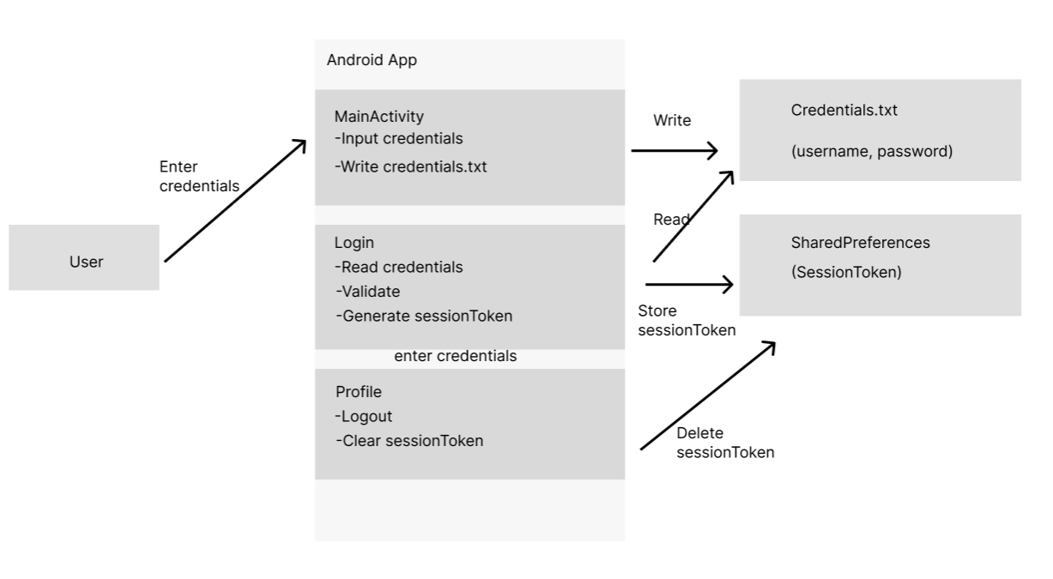
Figure 4
The application uses local authentication. All the information is stored in the "credentials.txt" file. The login status is confirmed by the existence of the "sessionToken" in the SharedPreferences. Therefore, I believe that hackers can read the "credentials.txt" file and steal the account passwords. Or they can modify the local file to impersonate users and access the system.
Task 3:Vulnerability Analysis
To identify security-relevant issues, we conducted static analysis focusing on randomness generation, session/token handling, cryptographic APIs, and password protection.
No cryptographic APIs were found in the application’s business logic, as all occurrences belong to Android framework libraries. We also observed that user credentials are stored and verified in plaintext, exposing them to direct compromise. However, since this issue is not related to randomness or cryptographic misuse within the assignment scope, it is considered out of scope.
For randomness analysis, two uses of java.util.Random were identified. The first appears in MainActivity.java:17–20, where new Random().nextInt(100) generates an integer for logging. As this value is not used in any security-sensitive context, it is considered a low-relevance issue.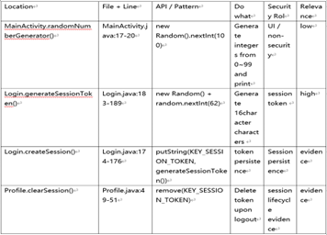

Figure 5
The second appears in Login.java:183–189, where generateSessionToken() uses java.util.Random to generate a 16-character alphanumeric session token. This token is stored in SharedPreferences and represents authentication state. Since java.util.Random is a deterministic pseudo-random number generator and does not provide sufficient unpredictability, this constitutes the primary vulnerability.
We further observed that no explicit validation of the session token is performed in the Profile component, suggesting a potential weakness in session management. However, this is not directly related to randomness misuse and is therefore not treated as the core issue.
In conclusion, while two random-related code locations exist, only the use in Login.java represents a security-relevant vulnerability due to its role in session authentication.

Task 4: Vulnerability Explanation and Attack Analysis
The vulnerability is located in Login.java within the generateSessionToken() function, where java.util.Random is used to generate session tokens. These tokens are stored and used to represent the authenticated state of the user. The root cause is the use of a non-cryptographically secure random number generator in a security-sensitive context.
A realistic attacker can obtain and decompile the APK, analyze the token generation logic, and observe application behavior. From this, the attacker can learn the token structure, including its length, character set, and generation method, and may also access locally stored tokens.
The attack proceeds as follows. The attacker reverse-engineers the APK and identifies the use of java.util.Random. By exploiting its predictability, the attacker reduces the search space or approximates the generation process. The attacker then attempts to predict or brute-force valid session tokens. If successful, the attacker can impersonate a legitimate user or hijack an active session.
This vulnerability weakens authentication integrity and may lead to unauthorized access or session hijacking.
Task 5: Mitigation and Security Recommendations
To mitigate this issue, the application should replace java.util.Random with SecureRandom, which provides cryptographically secure randomness. This ensures that session tokens are generated with sufficient entropy and are resistant to prediction.
In addition, token entropy should be increased by using longer random values and secure encoding methods. For example, generating raw random bytes and encoding them using Base64 or hexadecimal representation is preferred over manually constructing short strings.
The application should also clearly define session validation logic and avoid relying solely on locally generated tokens for authentication. Where possible, session tokens should be generated and validated on the server side to prevent client-side manipulation.
Furthermore, secure session management practices such as token expiration, regeneration after login, and proper invalidation on logout should be enforced. These measures help reduce the risk of session fixation and replay attacks, thereby strengthening overall authentication security.

